CS 255 System Design Document

UML Diagrams

UML Use Case Diagram

The UML use case diagram for the DriverPass system shows how different users interact with the system to complete important tasks. The system includes students, instructors, secretaries, IT administrators, the owner, and an external DMV system. Students are able to create accounts, log in, schedule lessons, take practice tests, and view their progress. Instructors can view lesson schedules and enter notes after lessons. Secretaries assist with entering student information and scheduling appointments. The IT administrator is responsible for managing user accounts and controlling access to the system, while the owner can generate reports and update service packages. The DMV system provides updates to ensure that test content remains accurate. This diagram ensures that all major system functions meet the needs identified in the DriverPass interview.
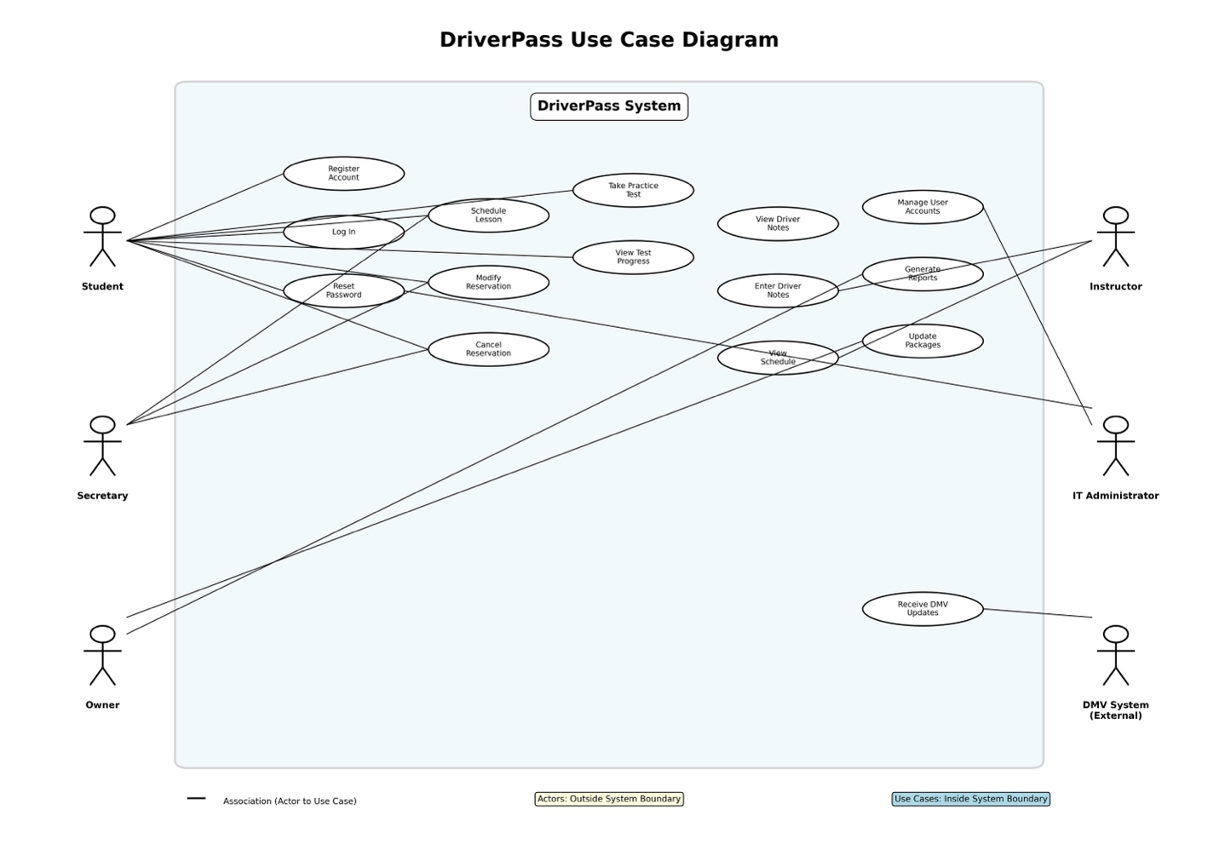

UML Activity Diagrams
The first activity diagram represents the process of scheduling a driving lesson. The process begins when the user logs into the system and selects a package. The user then chooses a date and time, and the system checks availability for instructors and vehicles. Once a valid option is selected, the reservation is confirmed and stored in the system. This ensures that scheduling is organized and avoids conflicts.
The second activity diagram represents the process of taking a practice test. The user logs into the system and selects a test. The system displays questions, and the user submits their answers. The system then grades the test and displays the score and completion status. This process supports DriverPass’s goal of helping students prepare effectively for driving exams.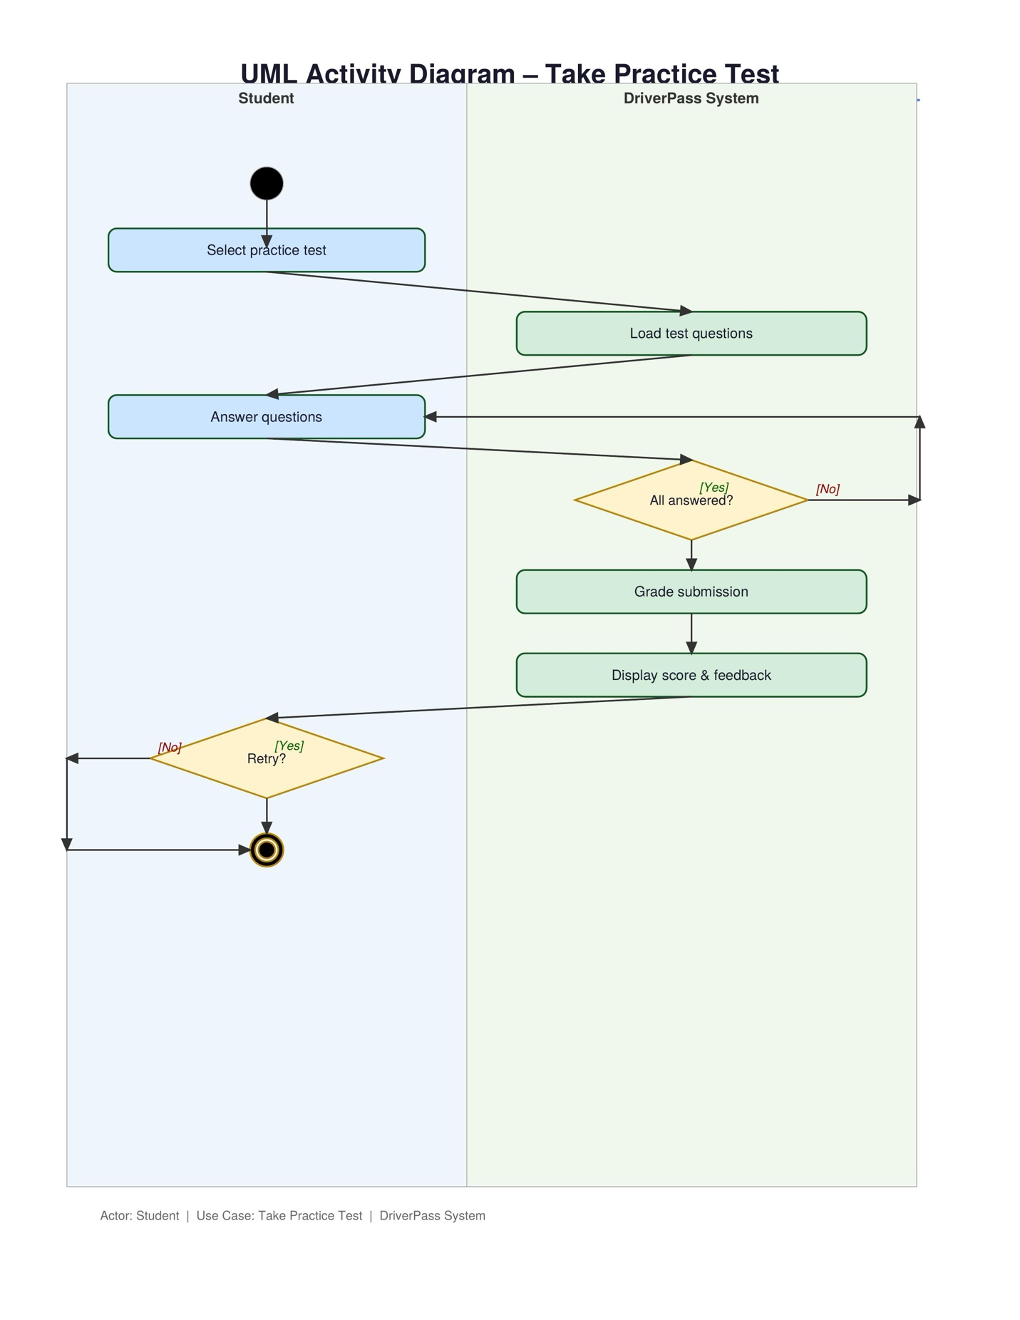

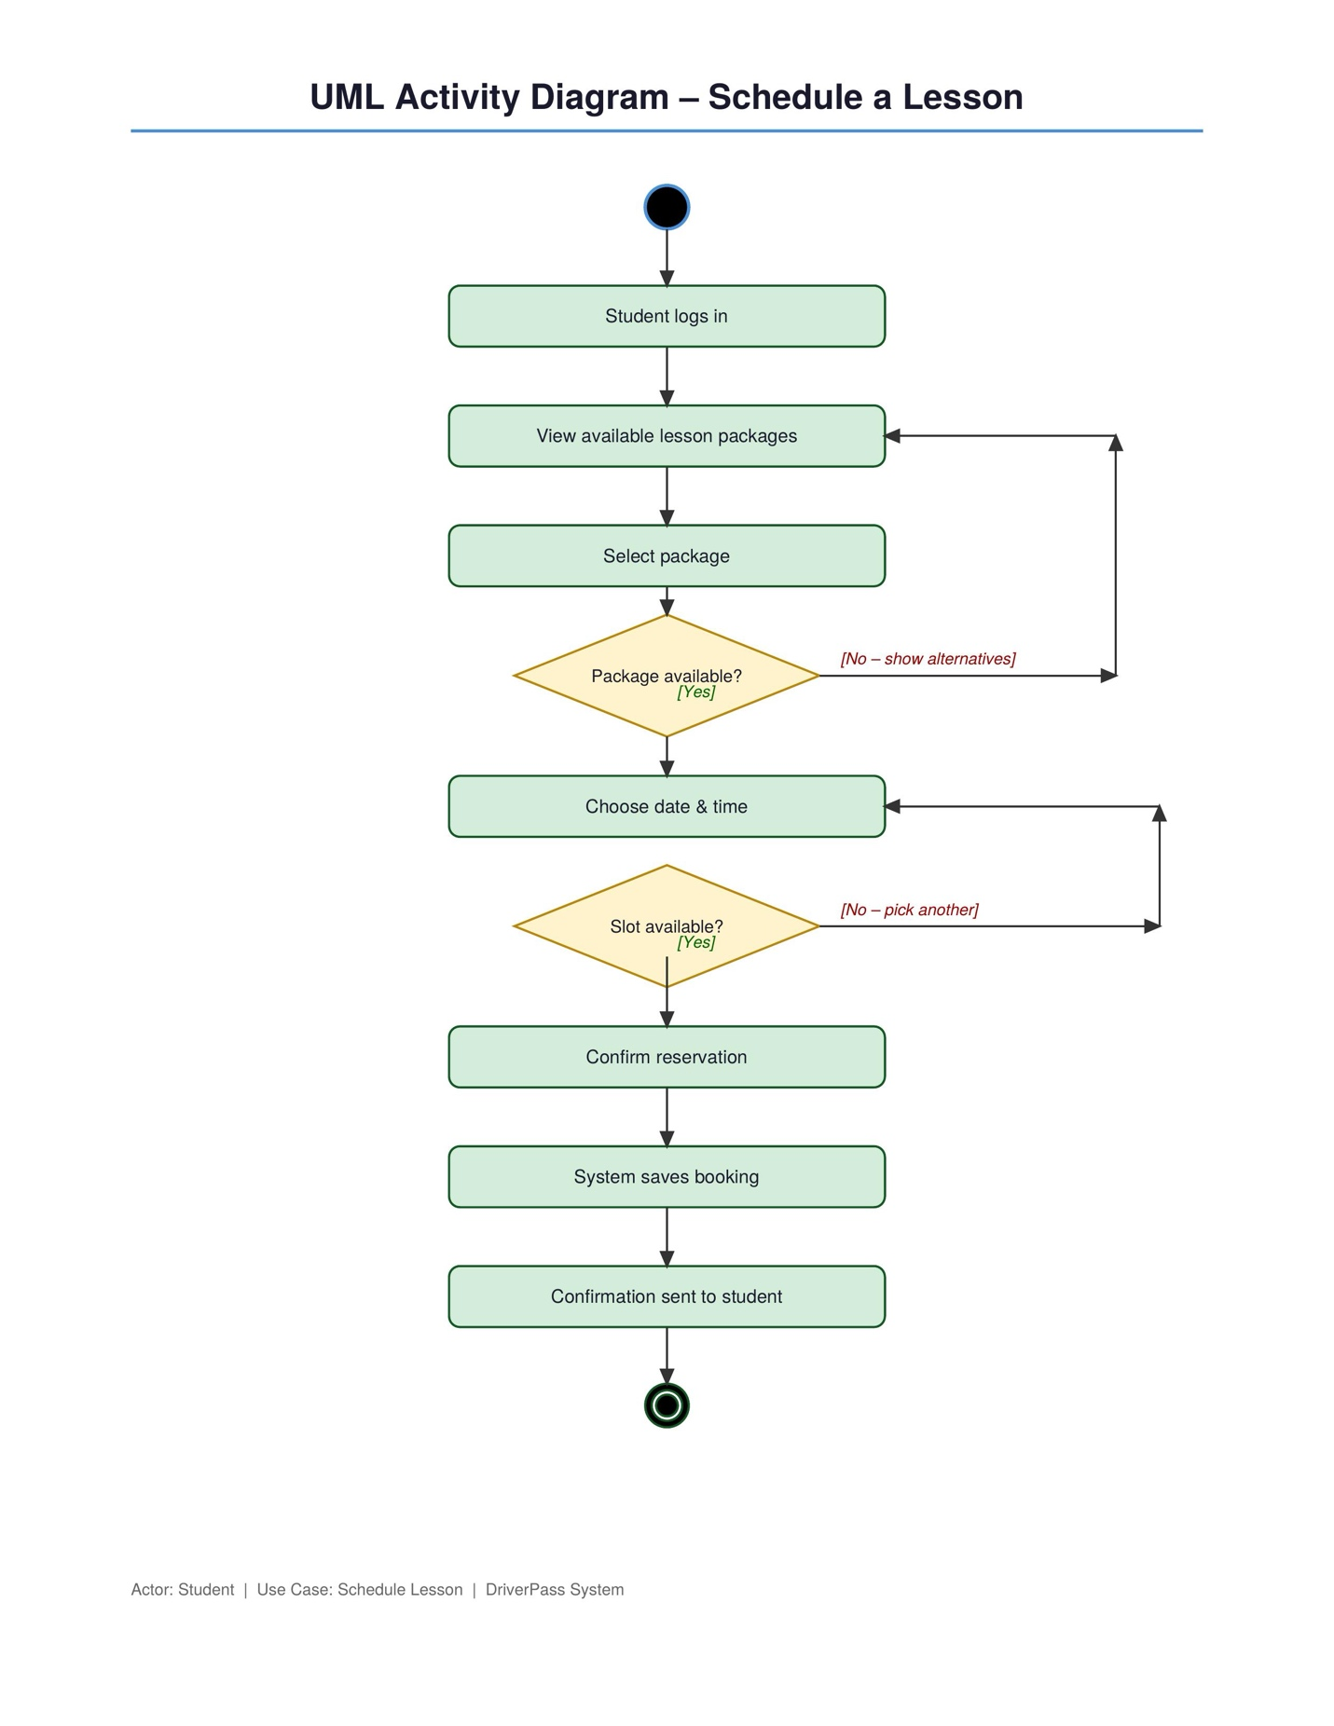

The sequence diagram shows how different parts of the system interact when a student schedules a lesson. The student sends a request to the system to schedule a lesson. The system then checks availability by communicating with the database. After receiving available options, the student selects a time. The system saves the reservation in the database and notifies the instructor. Finally, the system confirms the reservation back to the student. This process ensures accurate communication between system components and supports real time scheduling.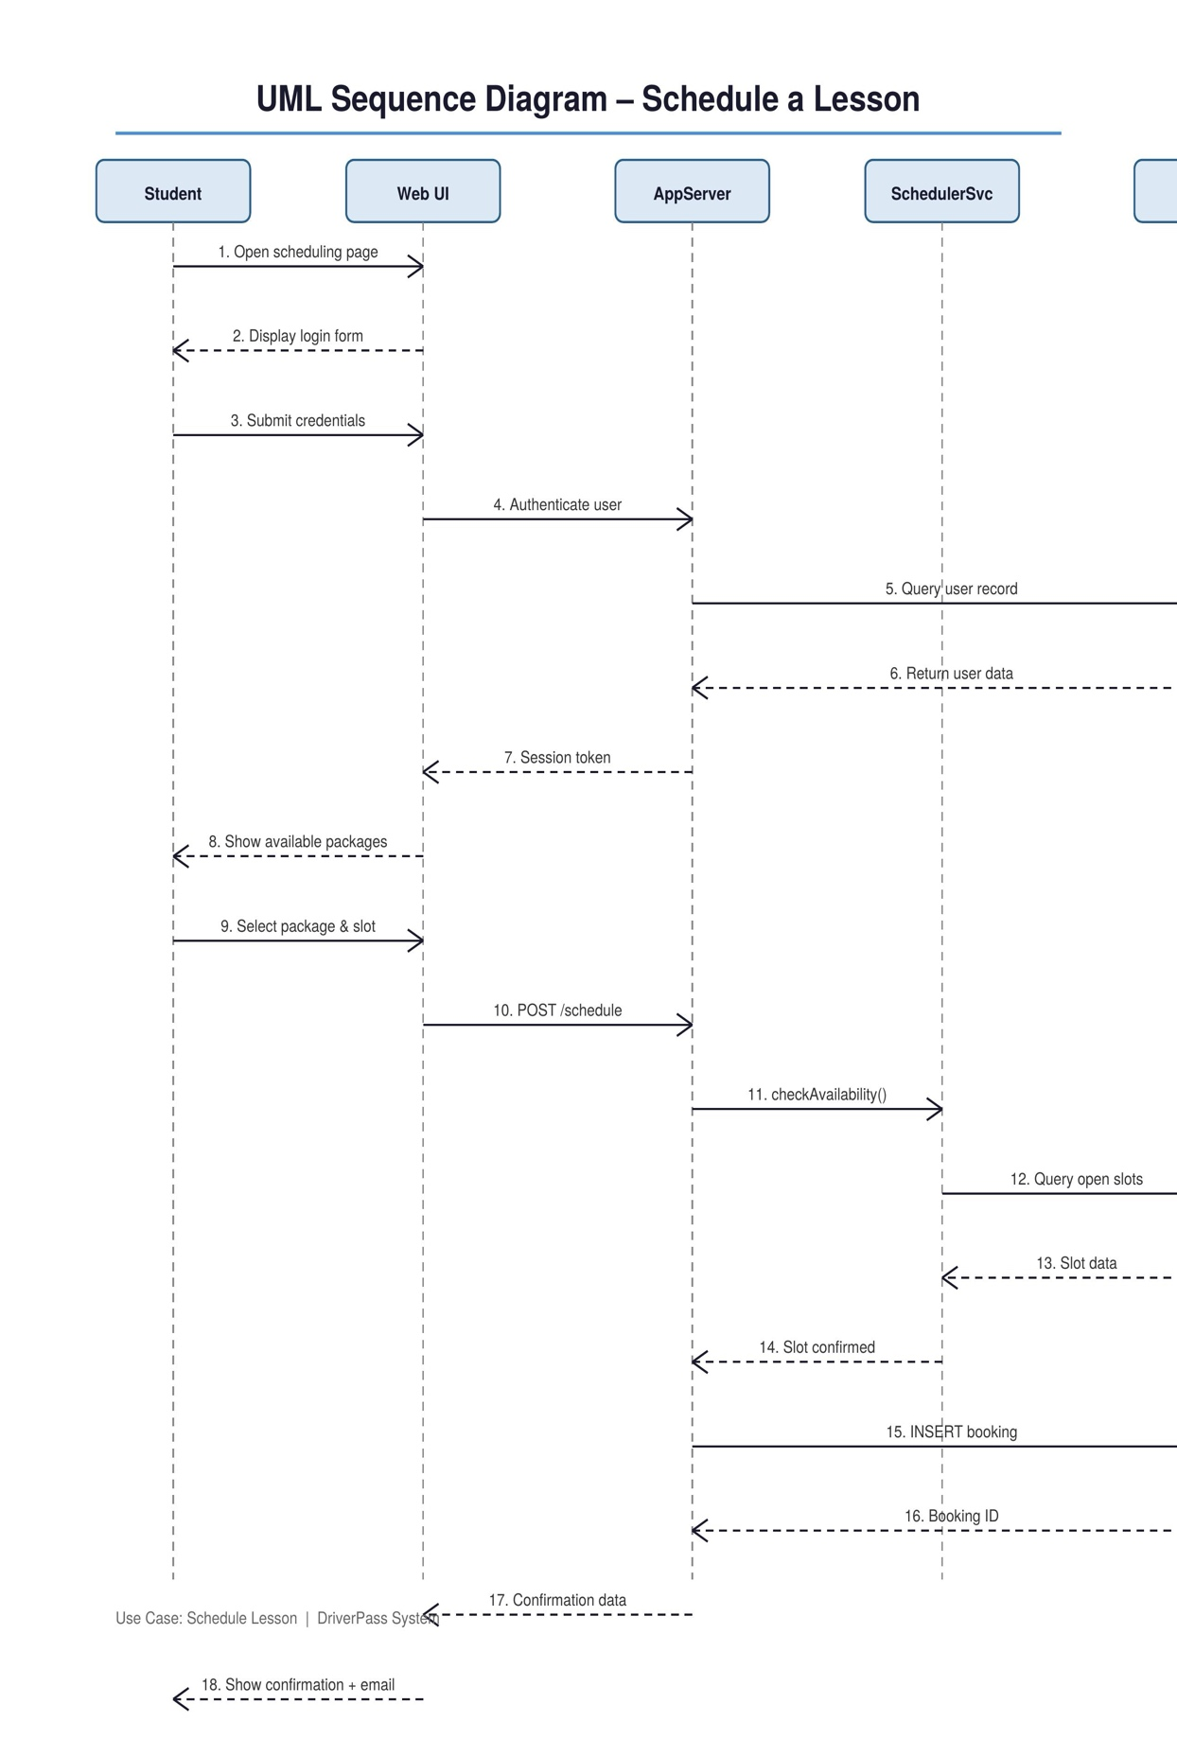

UML Class Diagram
The UML class diagram represents the structure of the DriverPass system by identifying key classes and their relationships. The system includes classes such as Student, Instructor, Secretary, IT Administrator, Owner, Package, Lesson, Reservation, Vehicle, and PracticeTest. Each class contains attributes relevant to its role, such as user information, lesson details, and test results. The relationships between classes allow the system to function properly. For example, a student is linked to reservations, reservations are connected to lessons, and lessons are assigned to instructors and vehicles. This structure ensures that the system is organized and capable of supporting all required features.
design meets the client’s requirements.]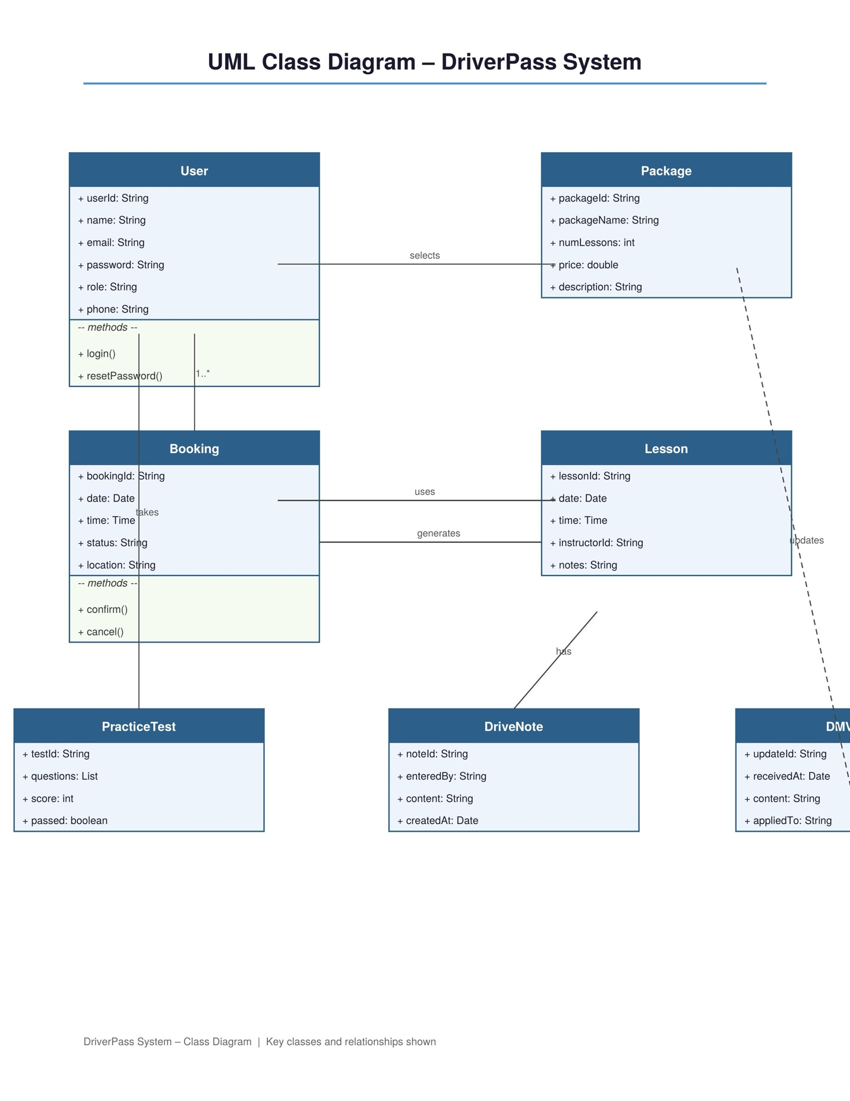

Technical Requirements

The DriverPass system will require a cloud based infrastructure to allow users to access the system from different devices and locations. The hardware requirements include secure web servers that can handle multiple users at the same time and store important data such as user information, lesson schedules, and test results. Users will access the system through devices such as computers, tablets, and smartphones. On the software side, the system will require a web based application, a database system to store and manage data, and secure login functionality to manage user accounts. The system must also support modern web browsers and be mobile friendly to ensure accessibility. In addition, the system will require integration with the DMV to receive updates for driving rules and test content. Security features such as encryption and controlled user access will be necessary to protect sensitive information. Backup systems will also be required to prevent data loss and maintain system reliability. These technical requirements ensure that the system is secure, efficient, and able to meet DriverPass’s needs.

